Posted 12/06/2010 at 9:10 am by JAV

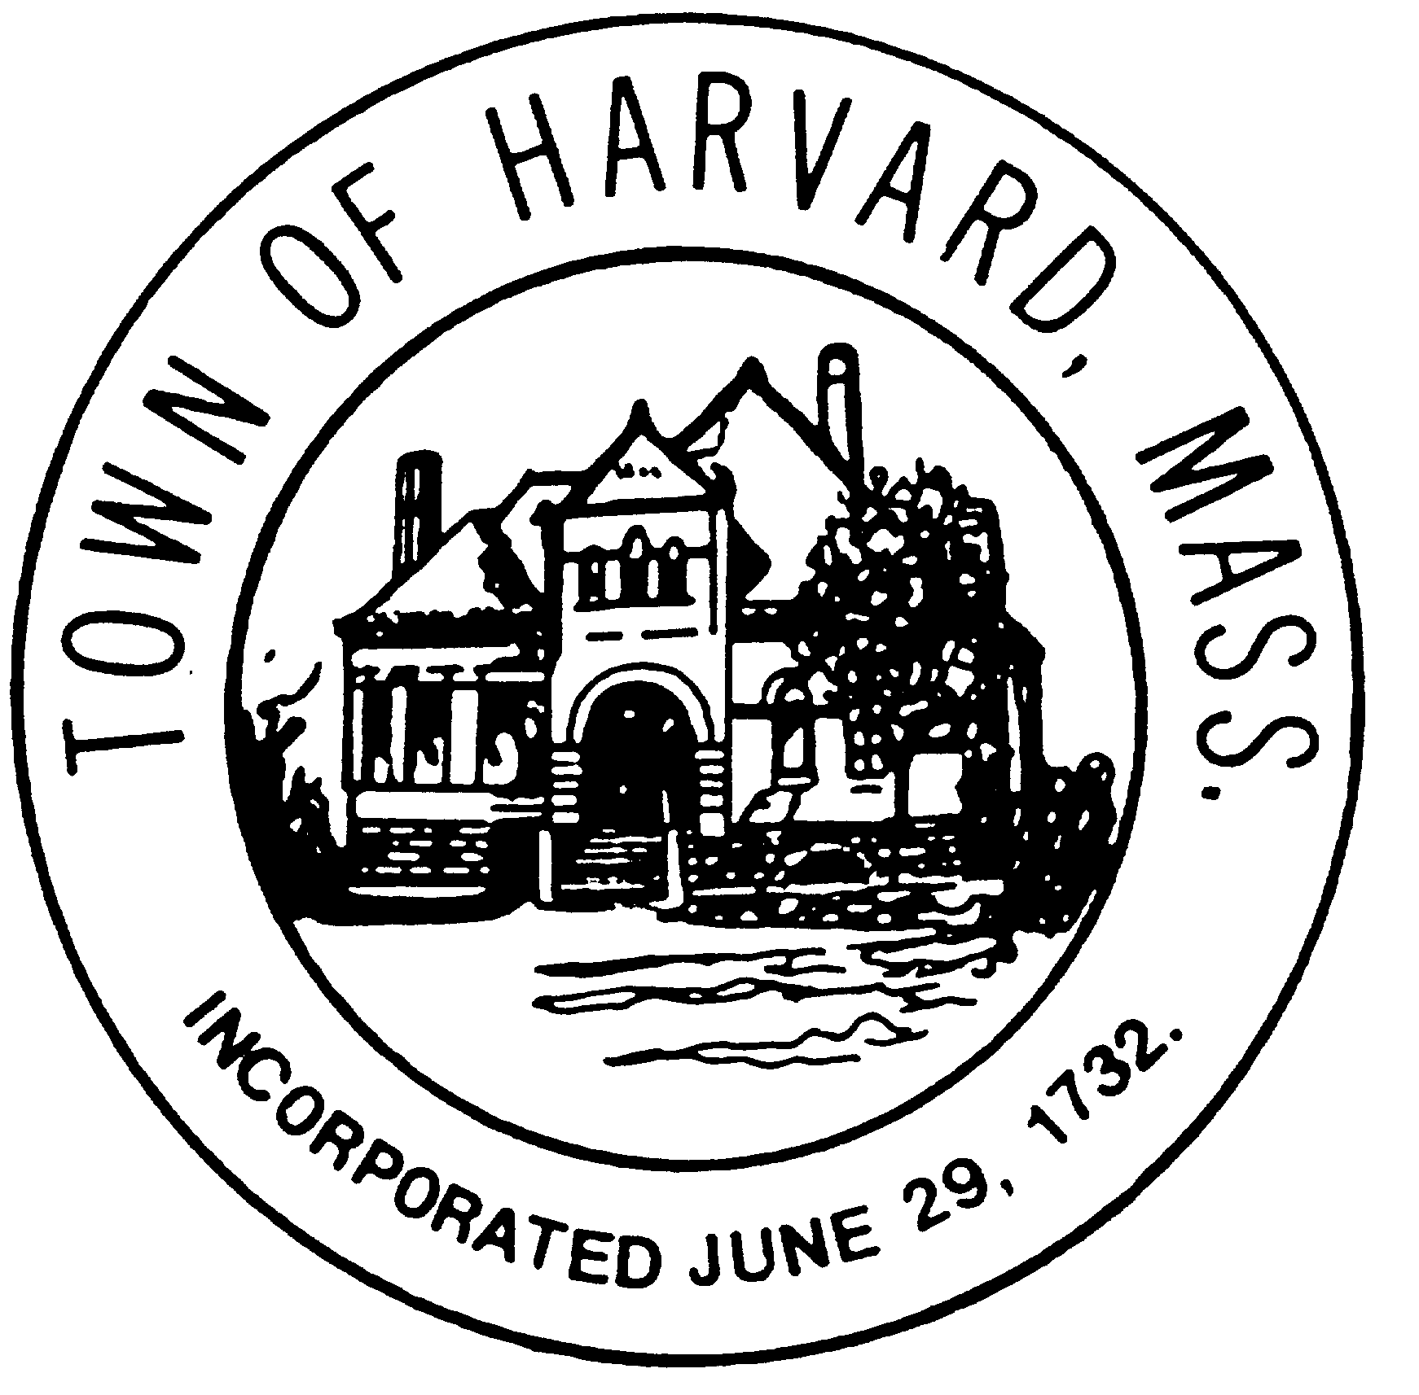
Board: Municipal Buildings Committee AGENDA
Day & Date: Thursday, December 9, 2010 Time: 9:30 – 11:30 am
Location: Town Hall meeting room
- Reading and approval of minutes of December 2nd meeting.
- Preparation of handout for Workshop #3
  - Handout:
    - Key components and assignments
      - Overview and explanation of the process (C. Ron)
      - Three programs; key ingredients and why? (Willie, Pete, Lucy)
      - Analysis of other civic spaces in town (Maggie)
      - Three Buildings and design schemes (Doug, Maggie, C. Ron)
        - Description of existing conditions
          - Requirement for code compliance
          - Location at heart of civic life of the town
        - Description and illustration of Schemes and Packages
        - Description of cost estimating process and components, and summary of benchmarking analysis
        - Cost estimates for each scheme and package
      - Early reports on Pilot Project (Willie)
      - Alternatives scenarios ranging from lowest cost to highest benefit, priced (Marie and C. Ron)
      - Recommended scenario (the various components drafted as Warrant Articles)
      - Financing strategy for Recommended Scenario (Marie, C. Ron )
        - Real estate – land sale of partial Hildreth (Peter); rezoning potential (Lucy and Scott)
        - Creation of a non-profit; explain strategy for 2nd year funding of Pilot Project (Willie)
        - Taking advantage of construction market (C. Ron)
        - Private giving (?)
        - Grant opportunities (Peter)
        - CPC/Green Communities/Energy rebates (Marie)
        - Phasing (need to discuss)
  - Process of editing, formatting and producing the document
- PR for Workshop
  - Press notices; Signs; E-mail
- Materials required for a program of public education in January/February/March
  - Background profile:
    - History of public-private partnerships for critical civic services in Harvard
    - History of the ‘common’ are center of civic life in Harvard
  - Laying the ground work for private philanthropy
  - Laying the ground work for a non-profit
  - A survey – electronic or something else
  - Handout including drawings

